Katie Hilliard

Module 2 Assignment

06/01/2025

**Tomcat**

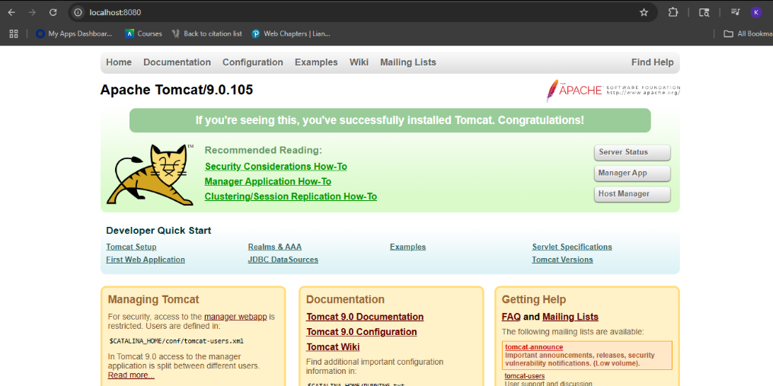

**Eclipse**



